Simple TestNG
TestNG is a testing framework for Java. It is used to create, organize, and run automated tests.
Right-click demo → Build Path → Configure Build Path → Libraries → Classpath → Add External JARs..

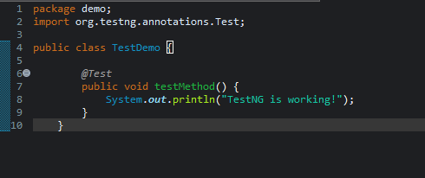

Output


